Sales Performance Dashboard Report
1. Introduction

This project analyzes sales performance using the Superstore dataset. The objective is to identify sales trends, profitability patterns, customer value, product performance, and customer retention behavior through interactive visualizations and data analysis.
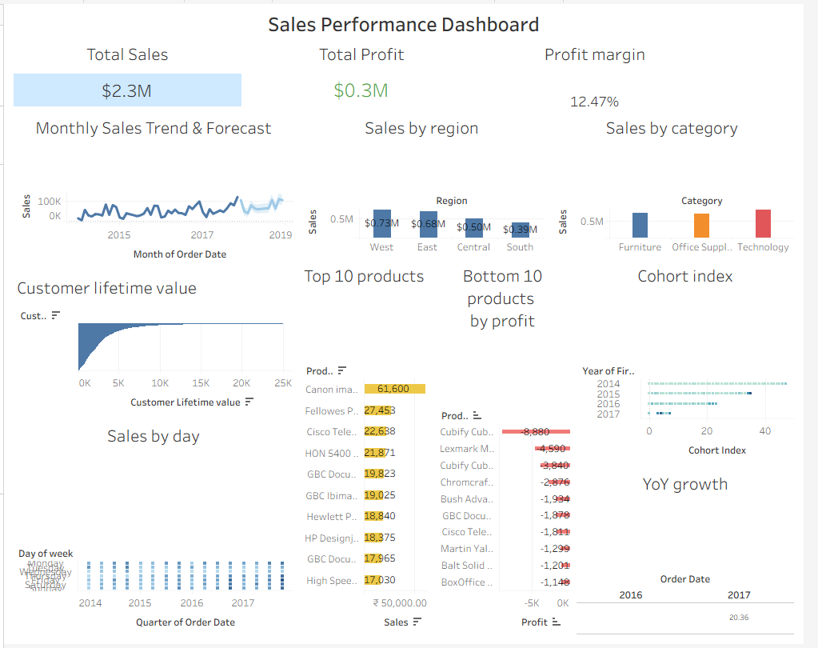
2. Key Performance Indicators (KPIs)
KPI Value
Total Sales $2.3M
Total Profit $0.3M
Profit Margin 12.47%

3. Dashboard Components
Monthly Sales Trend and Forecast
Analyzes sales performance over time and identifies future sales patterns using forecasting techniques.
Regional Sales Analysis
Compares sales performance across different geographical regions to identify high-performing markets.
Category Analysis
Evaluates sales generated by Furniture, Office Supplies, and Technology categories.
Product Performance Analysis
Identifies the top 10 revenue-generating products and the bottom 10 products with the lowest profitability.
Customer Lifetime Value (CLV)
Measures the long-term value generated by customers.
Cohort Analysis
Evaluates customer retention and purchasing behavior over time.
Year-over-Year Growth Analysis
Measures annual business growth and performance trends. KPIs provide an overview of the company's overall business performance and profitability.
4. Key Insights
Insight 1: West Region Generated the Highest Sales
The West region recorded the highest sales among all regions, indicating strong market performance and customer demand.

Insight 2: Technology Category Was the Best Performing Category
Technology products generated the highest sales compared to Furniture and Office Supplies, making it the most valuable product category.

Insight 3: Profit Margin Remained Healthy
The company achieved a profit margin of 12.47%, demonstrating effective cost management and profitability.

Insight 4: Canon ImageClass Was the Top Revenue-Generating Product
The Canon ImageClass product generated the highest revenue among all products and contributed significantly to overall sales.

Insight 5: Certain Products Generated Significant Losses
Products such as Cubify CubeX 3D Printer showed negative profitability, indicating the need for pricing or inventory optimization strategies.

5. Recommendations
Recommendation 1
Increase investment and marketing efforts in the West region to maximize sales opportunities.

Recommendation 2
Expand the Technology product category by introducing complementary products and promotional campaigns.

Recommendation 3
Review pricing strategies for loss-making products and discontinue consistently unprofitable items if necessary.

Recommendation 4
Implement targeted customer retention programs to improve repeat purchases and increase customer lifetime value.

Recommendation 5
Use sales forecasting results to optimize inventory planning and reduce stock shortages during high-demand periods.

6. Conclusion
The Sales Performance Dashboard successfully provides insights into sales trends, profitability, customer behavior, and product performance. The analysis highlights growth opportunities in high-performing regions and categories while identifying areas requiring strategic improvement. The dashboard can support data-driven decision-making and improve overall business performance.

